1. Dice Throw Problem using Dynamic Programming

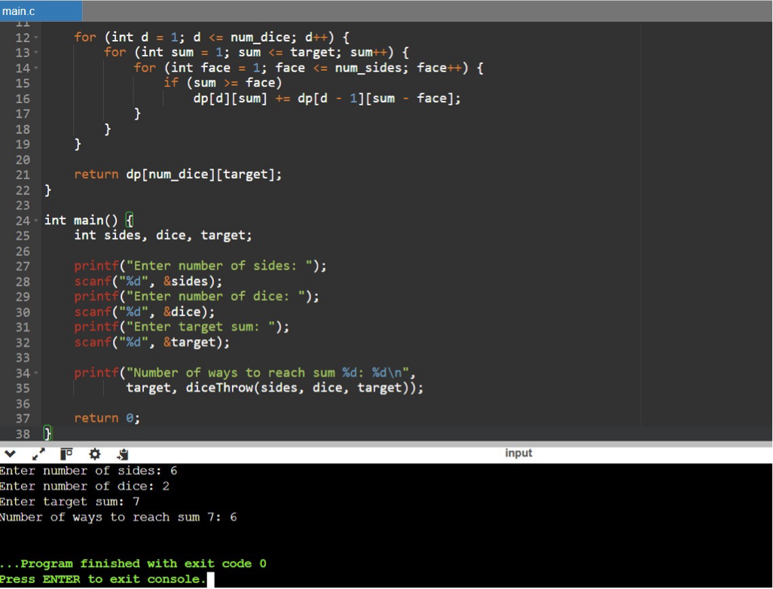

2. Assembly Line Scheduling using DP

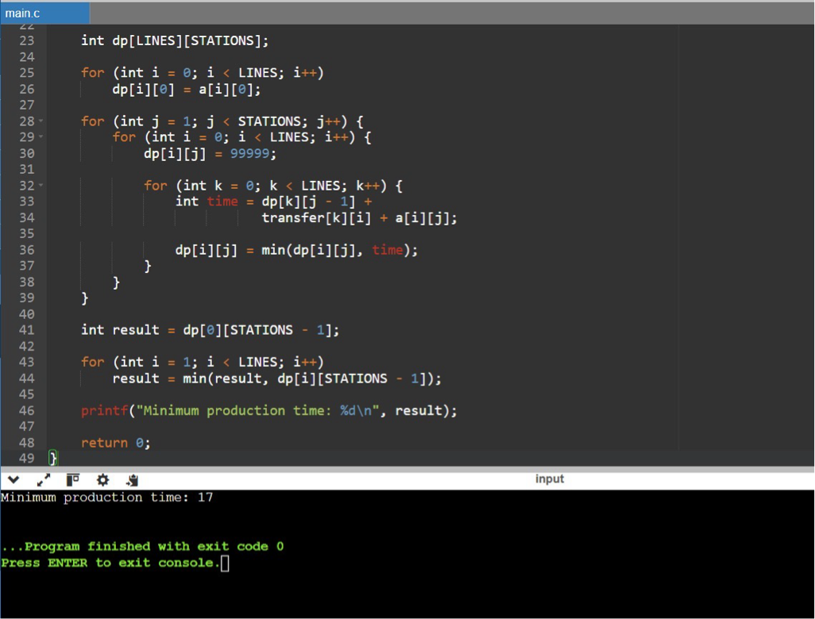

3. Three Assembly Lines – Minimum Production Time

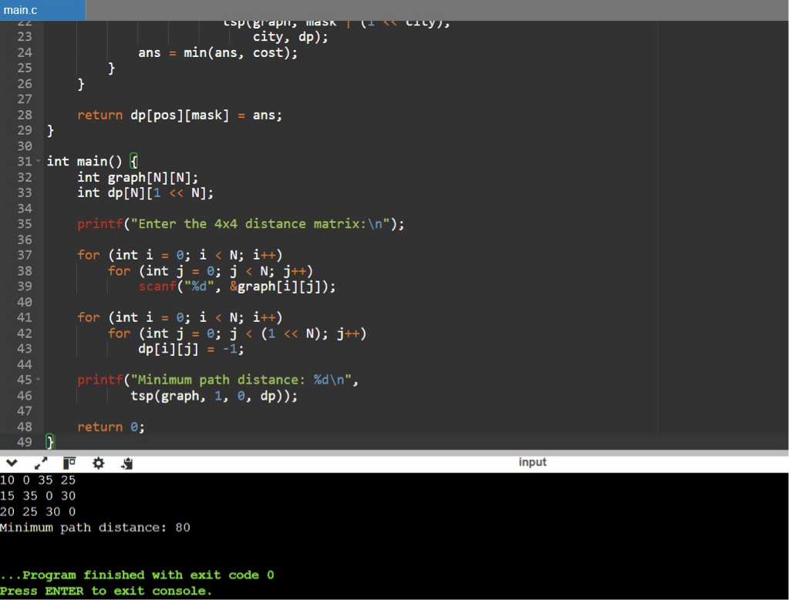

4. Minimum Path Distance using Matrix Form

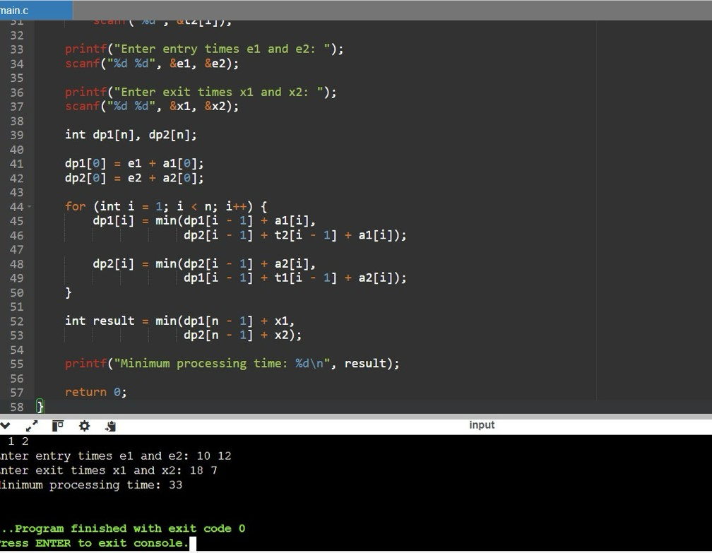

5. TSP with 5 Cities

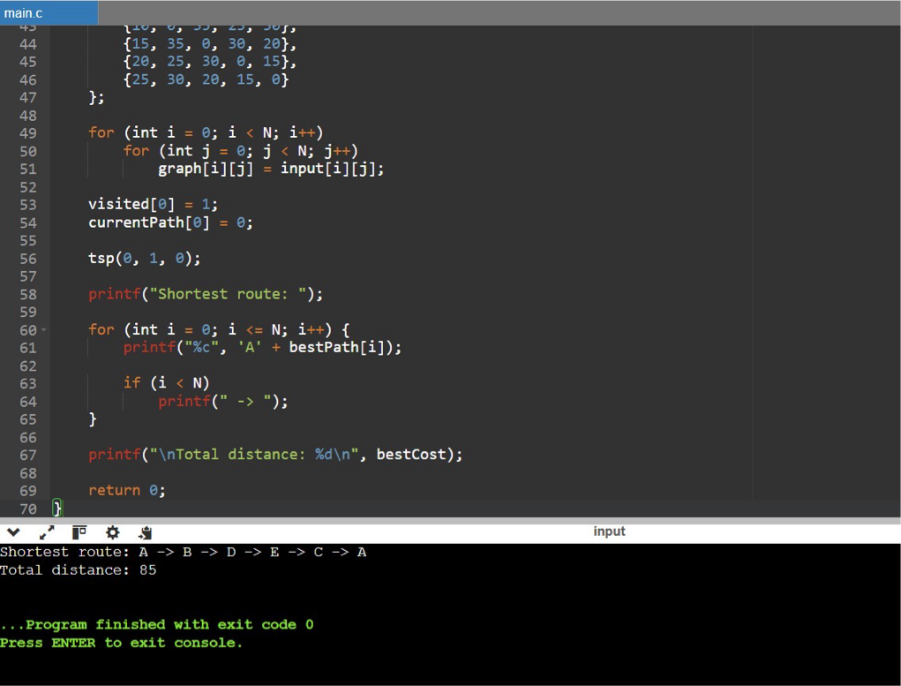

6. Longest Palindromic Substring

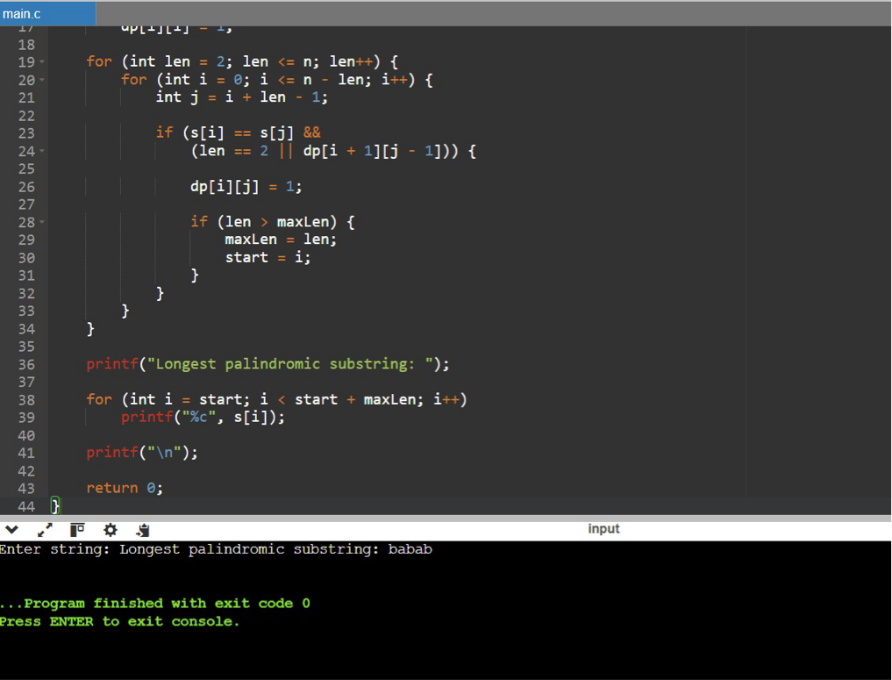

7. Longest Substring Without Repeating Characters

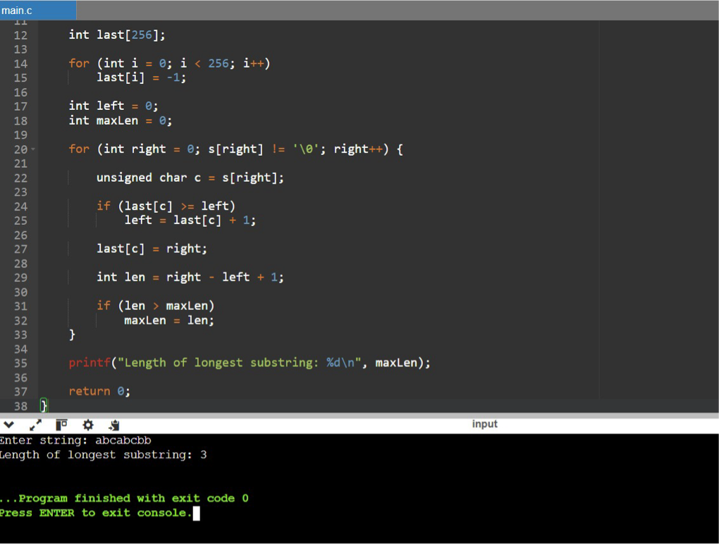

8. Word Break Problem

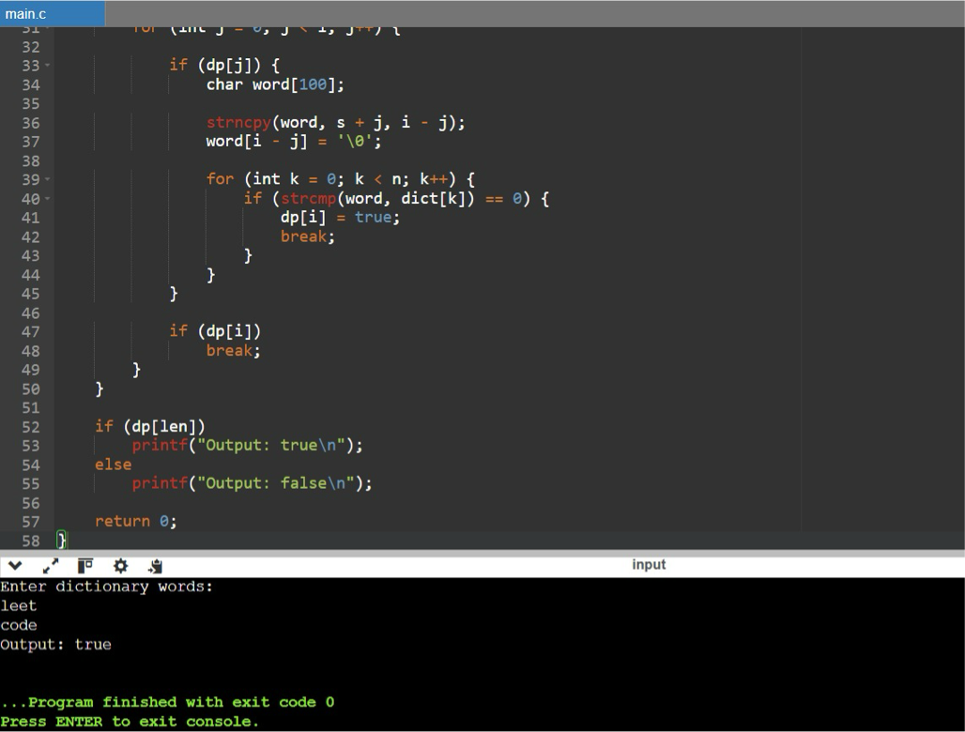

9. Word Break using Given Dictionary

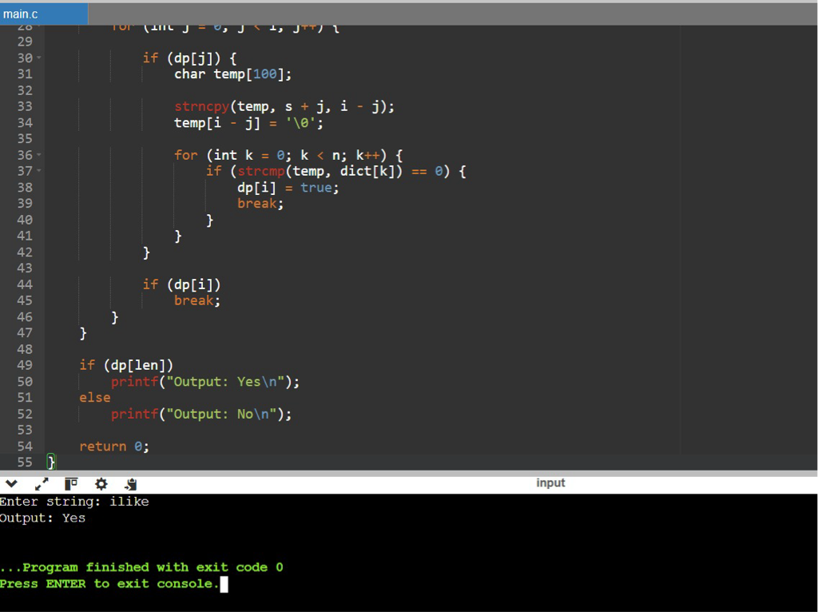

10. Text Justification

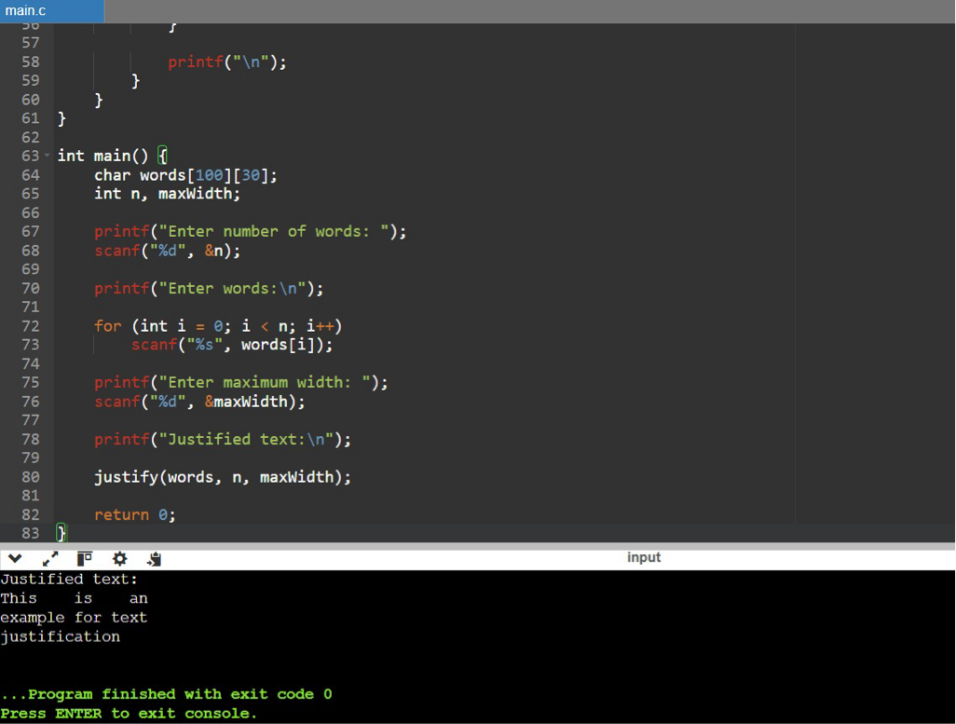

11. WordFilter – Prefix and Suffix Search

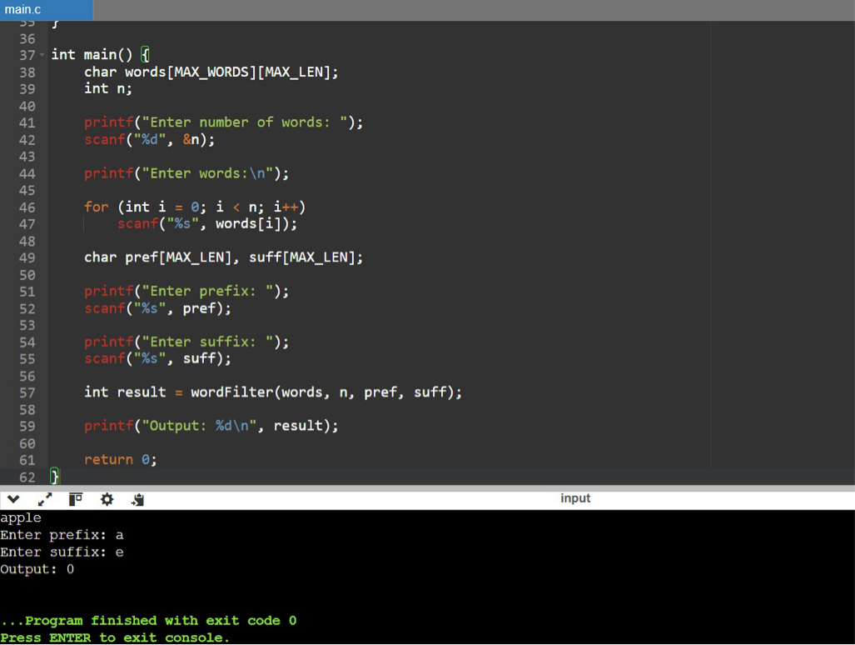

12. Floyd's Algorithm – All-Pairs Shortest Path

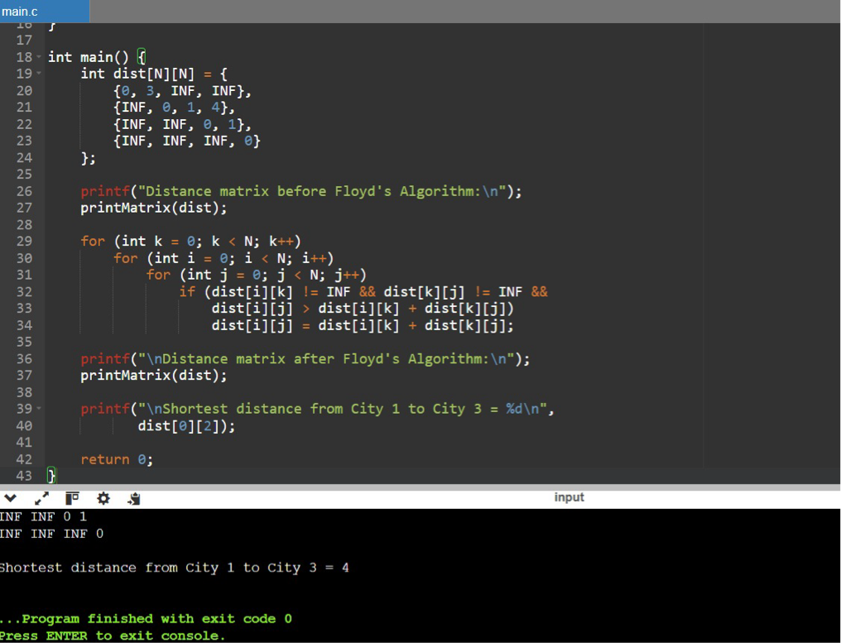

13. Floyd's Algorithm – Router Link Failure

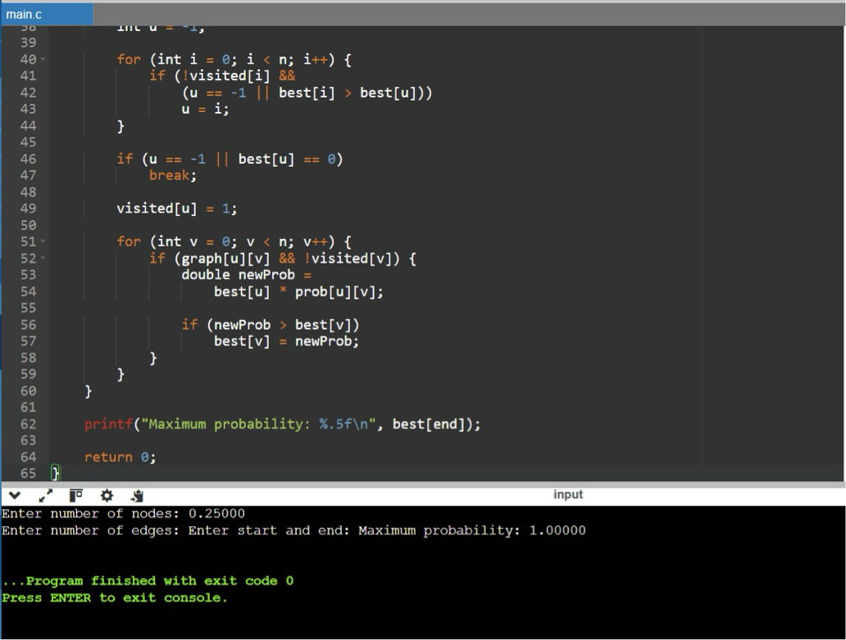

14. Floyd's Algorithm – City Network

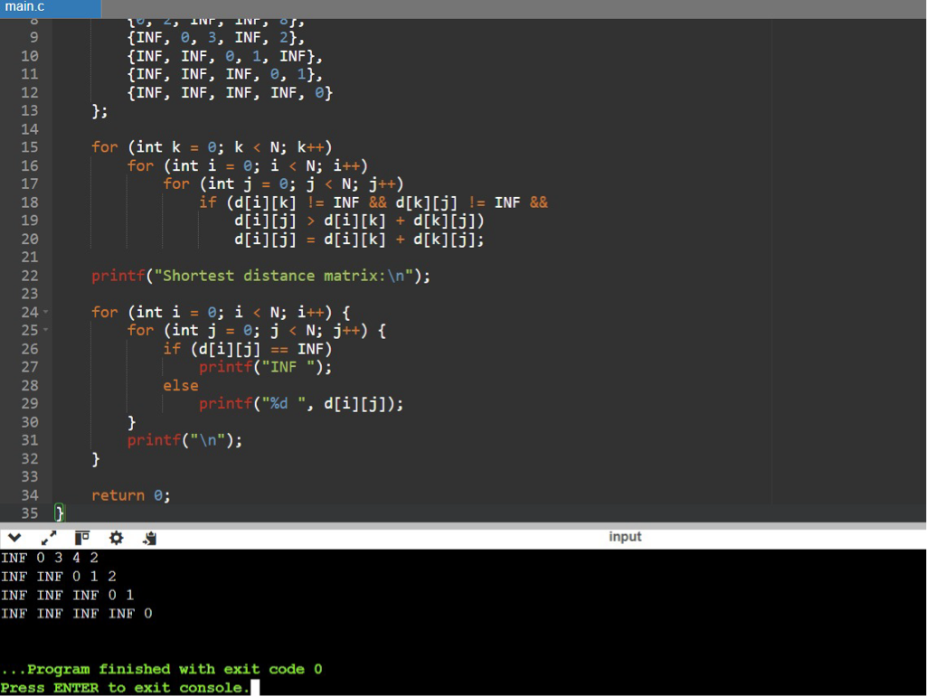

15. Optimal Binary Search Tree

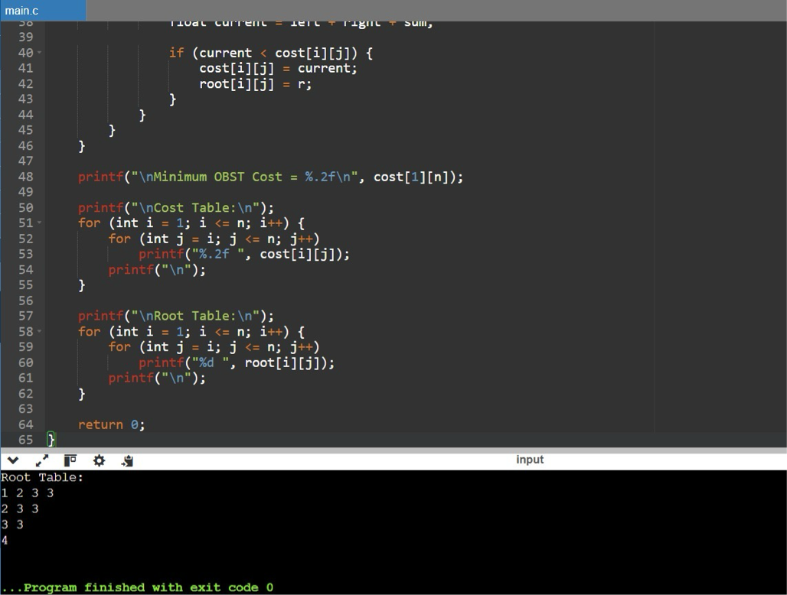

16. OBST – Keys 10, 12, 16, 21

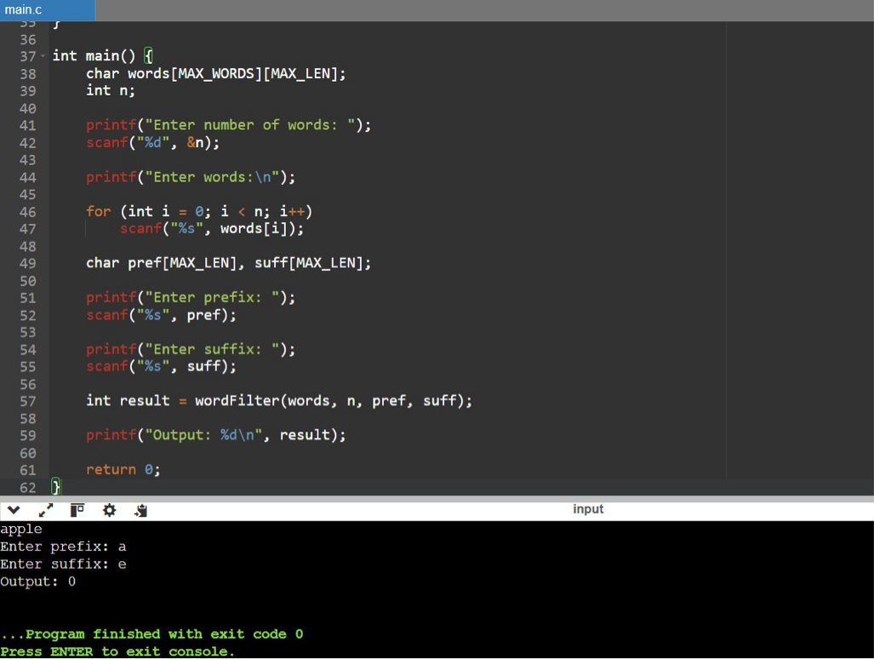

17. Cat and Mouse Game

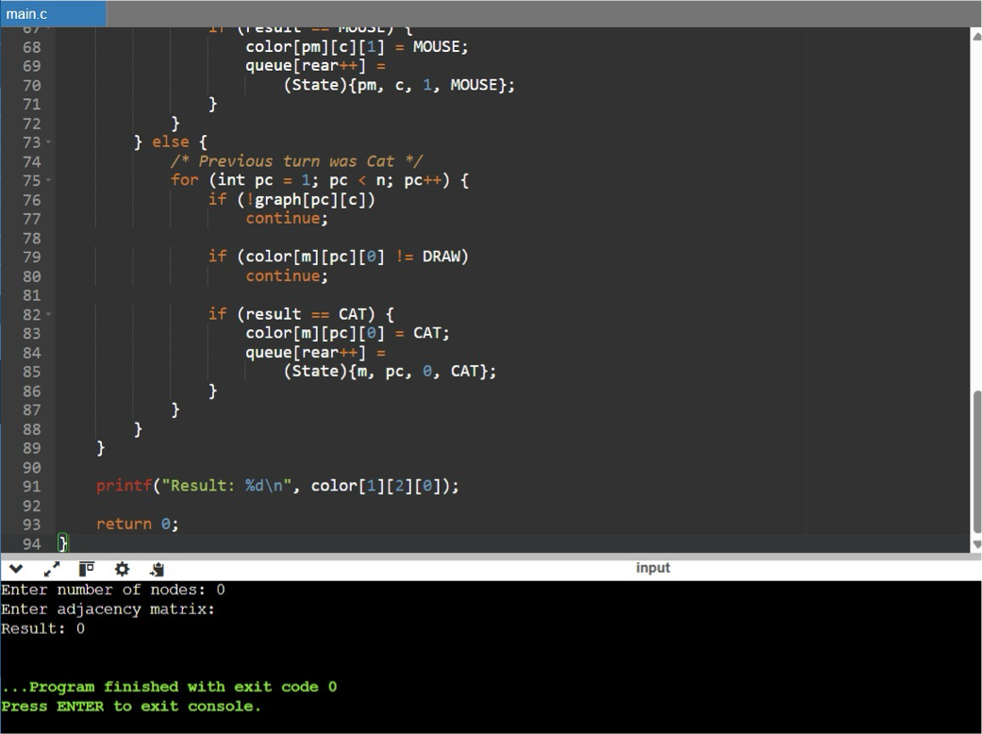

18. Maximum Probability Path

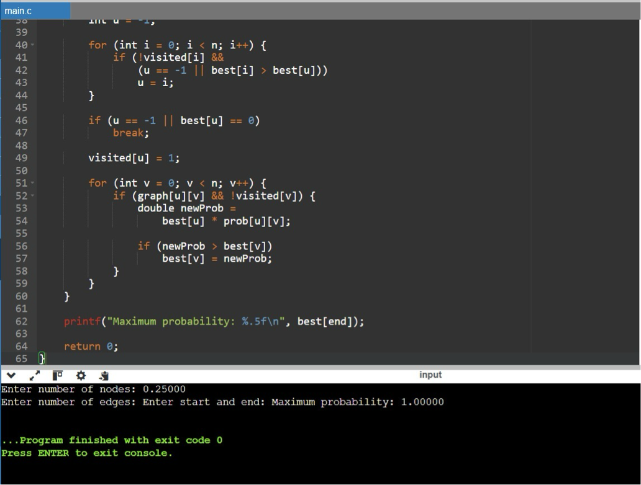

19. Unique Paths in a Grid

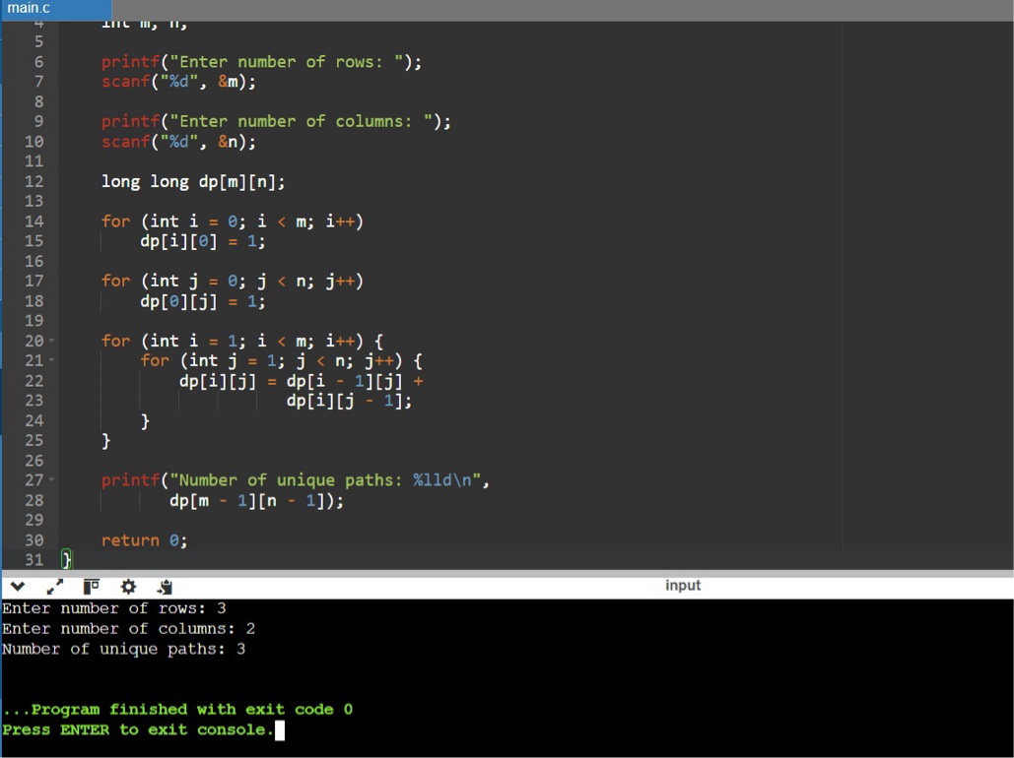

20. Number of Good Pairs

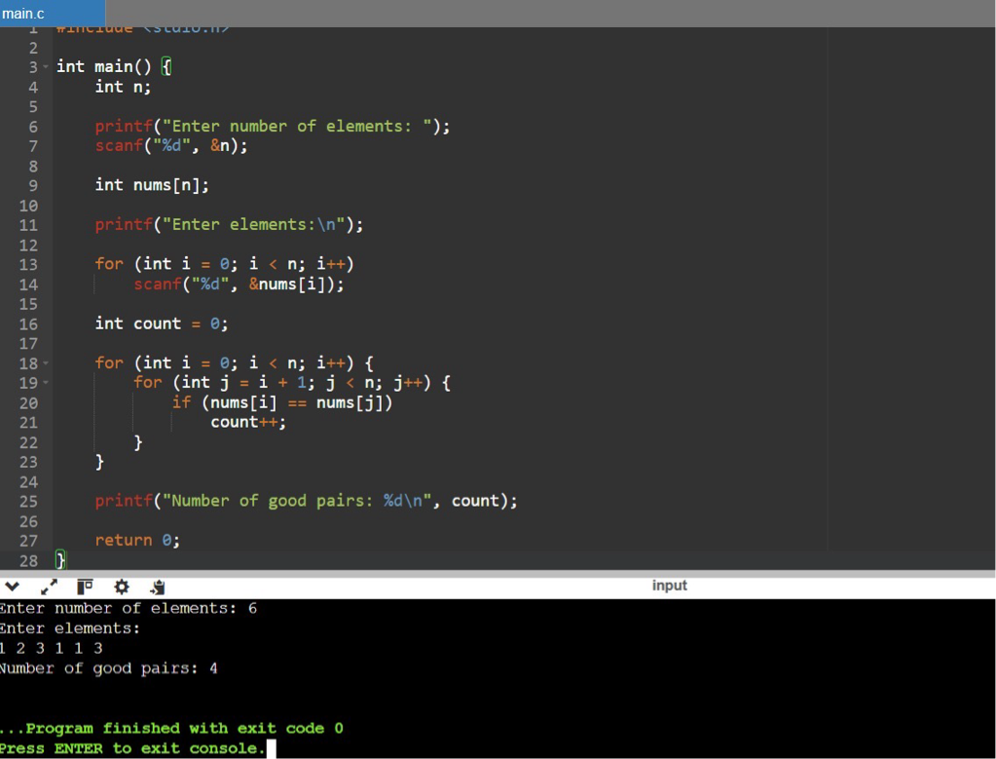

21. Find City with Smallest Number of Neighbors

